BS CYBER SECURITY PROGRAM, DEPARTMENT OF COMPUTER SCIENCE. HITEC UNIVERSITY TAXILLA.

***SYED ALI AHMED HASHMI***

***REG NO : 24-CyS-058***

***DEPARTMENT : CYBER SECURITY***

***SEC : A***

***COURSE : ARTIFICIAL INTELLIGENCE LAB***

***SUBMITTED TO : SIR MUBASHIR IQBAL***

***LAB REPORT :02***

Q 1: Count the number of strings where the string length is 2 or more and the first and last character are same from a given list of strings. Sample List: ['abc', 'xyz', 'aba', '1221', 'xyzzyx', 'aa', '122’] Expected Result: 4 .

***CODE:***

# Sample list

words = ['abc', 'xyz', 'aba', '1221', 'xyzzyx', 'aa', '122']

count = 0

for word in words:

    if len(word) >= 2 and word[0] == word[-1]:

        count += 1

print("Number of strings with same first and last character:", count)

***OUTPUT:***

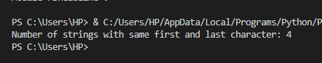

Q 2: Find the sum and product of numbers in a tuple. Sample List: (1, 2, 4, 2, 6), Sum is: 15, Product is: 96.

***CODE:***

numbers = (1, 2, 4, 2, 6)

# Calculate sum

sum_of_numbers = sum(numbers)

# Calculate product

product_of_numbers = 1

for num in numbers:

    product_of_numbers *= num

print("Sum is:", sum_of_numbers)

print("Product is:", product_of_numbers)

***OUTPUT:***

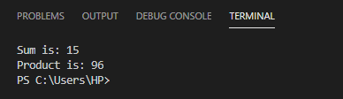

Q 3 :Write a program to print largest number in a List Sample List: (1, 2, 4, 2, 6).

***CODE:***

numbers = [1, 2, 4, 2, 6]

# Find the largest number

largest = max(numbers)

# Display the result

print("The largest number in the list is:", largest)

***OUTPUT:***

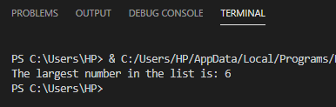

Q 4: Write a Python program to remove an empty tuple(s) from a list of tuples. Sample L = [(), (),('',), ('a', 'b'), (), ('a', 'b', 'c'), (), ('d')], Result = [('',), ('a', 'b'), ('a', 'b', 'c'), ('d')].

***CODE:***

L = [(), (), ('',), ('a', 'b'), (), ('a', 'b', 'c'), (), ('d',)]

# Remove empty tuples using list comprehension

result = [t for t in L if t]

print("Result =", result)

***OUTPUT:***

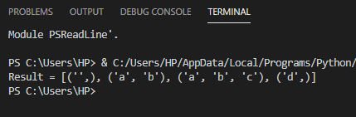

Q 5 :Write a Python script to generate and print a dictionary that contains a number (between 1 and n) in the form (‘x’, x*x). Sample: Input a number 4 Output: {'1': 1, '2': 4, '3': 9, '4': 16}.

***CODE:***

n = int(input("Input a number: "))

# Create dictionary using loop

result = {}

for x in range(1, n + 1):

    result[str(x)] = x * x

# Print the result

print(result)

***OUTPUT:***

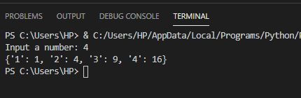

Q 6 :Create a program using Dictionary that takes Numbers as input and print it inwords form Sample: Input: 1234, Output: One Two Three Four.

***CODE:***

num_to_word = {

    '0': 'Zero',

    '1': 'One',

    '2': 'Two',

    '3': 'Three',

    '4': 'Four',

    '5': 'Five',

    '6': 'Six',

    '7': 'Seven',

    '8': 'Eight',

    '9': 'Nine'

}

# Taking number input from the user

number = input("Enter a number: ")

# Converting each digit to its word form

output = ""

for digit in number:

    if digit in num_to_word:

        output += num_to_word[digit] + " "

# Display result

print("Output:", output.strip())

***OUTPUT:***



